Bipedal Humaoid Robot

Documentation of CAD Creation and 3D Printing

Portland State University

Agile and Adaptive Robotics Laboratory

Contents

Designing the CAD Parts 2

Skeleton File 2

Ilium 2

Splitting the Ilium In Half 2

Femoral Head and Ball 2

Sacrum 2

Plotting XYZ Cloud Points 2

3D Printing 4

Printing the Ilium: 4

Trial 1 4

Other Ideas 4

*Printing the Ilium Cover* 5

Printing the Femoral Head and Ball 6

Assembly 6

# Designing the CAD Parts

### Skeleton File

A base file with the main sketches that are referenced by other parts to make cuts and extrusions. These sketches can be adjusted and will be updated throughout all other referenced parts.

## Ilium

### Splitting the Ilium In Half

1. Splitting the ilium in half will allow the part to be printed easier
   1. The ilium needs to be rigid since muscle connection are located throughout the ilium
   2. Placing bolts to connect 2 ilium pieces is a bit awkward due to the shape of the ilium
   3. Dowel pins can be placed to make the connection stronger
   4. Consideration of how to split the part.
      1. Horizontal - 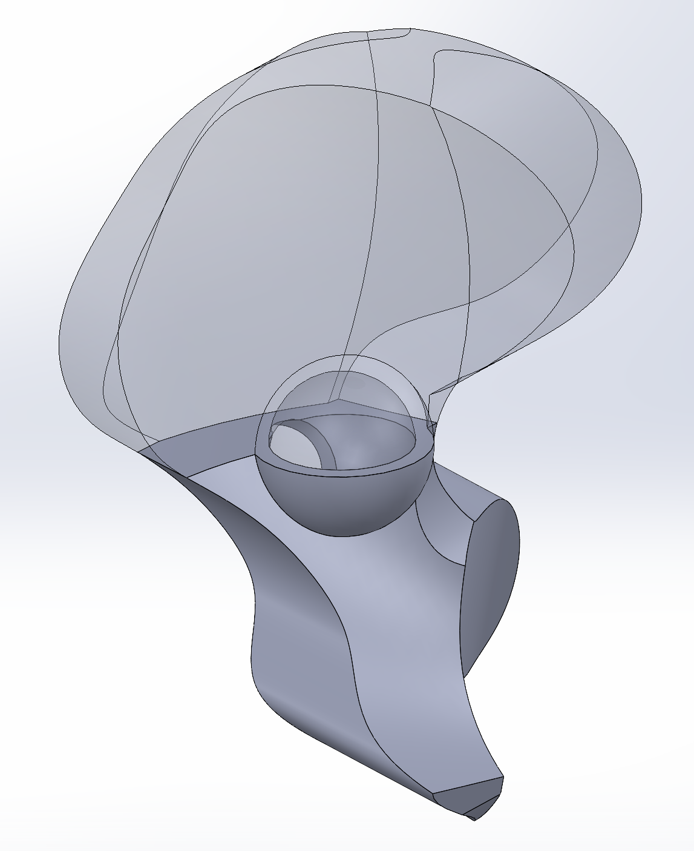
         1. Allows ball to be placed without a need for a cover
         2. Hard to connect the 2 parts since there is a small cross sectional area
      2. Vertical
         1. Easier to connect the 2 pieces

## Femoral Head and Ball

## Sacrum

## Plotting XYZ Cloud Points

Plotting OpenSim4.0 Points in SolidWorks

1. Log into PSU Lab SolidWorks
2. Open excel file where points are stored
3. Convert them to mm filling in the first 3 columns
4. Save as ‘Formatted Text’ Space delimited File
5. Open in the .prn file in notepad
6. Save as a .txt file
7. Select SolidWorks AddIns and Click ‘ScanTo3D’
8. Press ‘File’ -> ‘Open’
9. Select file type ‘ScanTo3D Point Cloud Files’’
10. Find .Txt Document File
11. Press Open
12. Confirm length is correct by measuring
13. Create a 3D sketch
14. Select the point tool
15. Start clicking away at the point cloud points
16. Exit 3D sketch
17. Delete the Point Cloud

# 3D Printing

## Printing the Ilium:

### Trial 1

Printed 2 times and failed

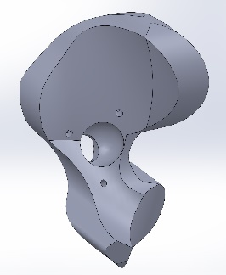



The print failed twice at the overhang where the plastic lifted up and the extruder caught onto it and pulled part off the bed:

### Other Ideas

1. Change the angle at which the part prints
   1. Add fillets
2. Split the part in 2 pieces and print.
   1. 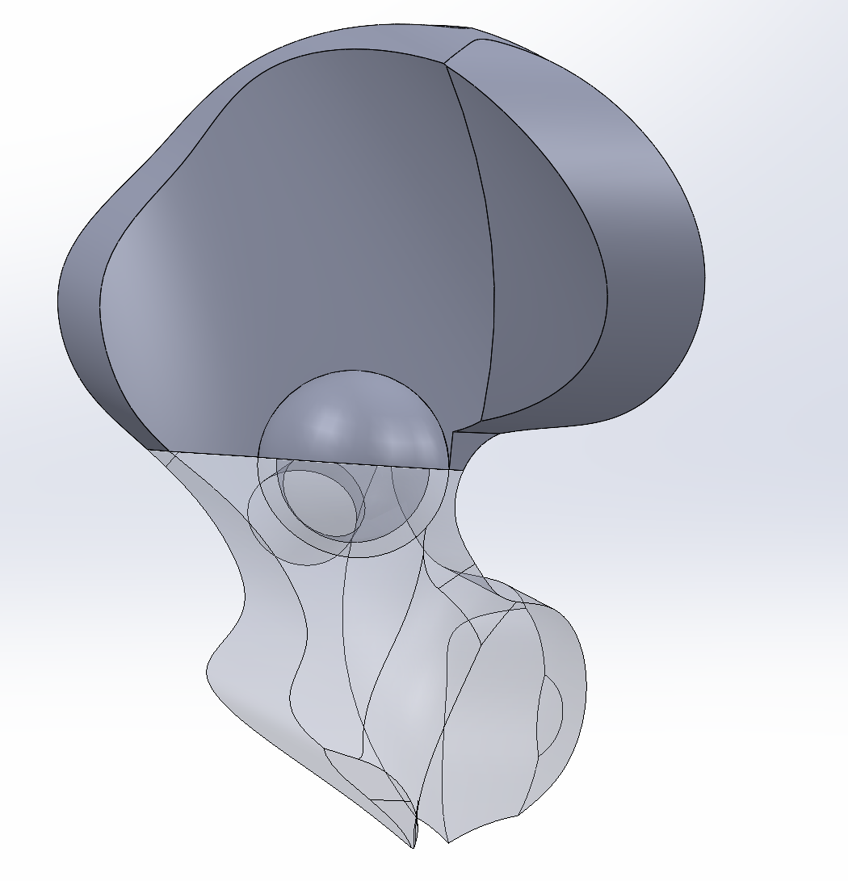
   2. This design allows the 2 pieces to connect together with the ball placed inside without the need for a cover, however, we are struggling to find the best way to connect the 2 pieces together since cross sectional area
   3. Another idea is to have the 2 piece ilium + the cover to hold everything together

## *Printing the Ilium Cover*

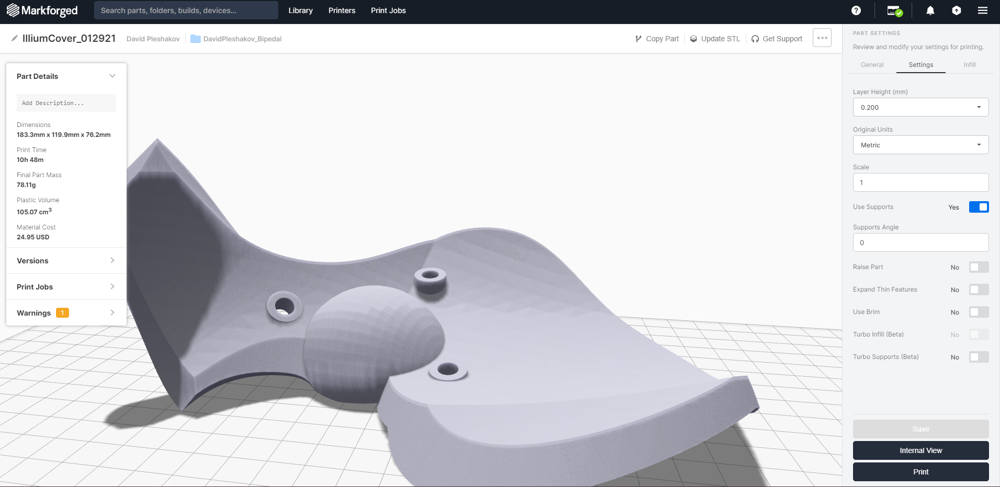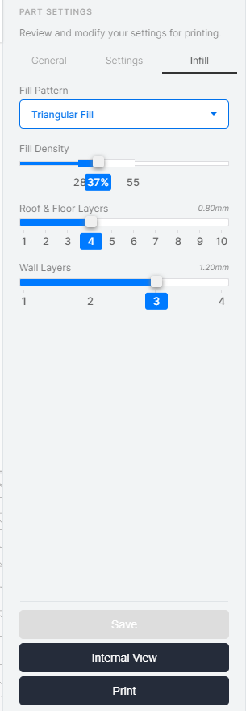

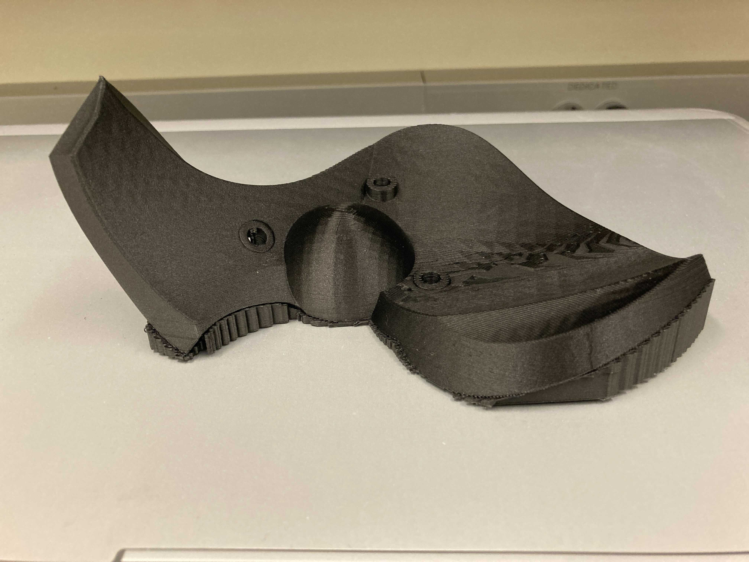

Placed on the flattest bottom part. The part printed well with no issues

## Printing the Femoral Head and Ball

 



# Assembly